BON JOUR UNPLUGGED
DESIGN PHILIPPE STARCK, 2015
2025 NEW RELEASE

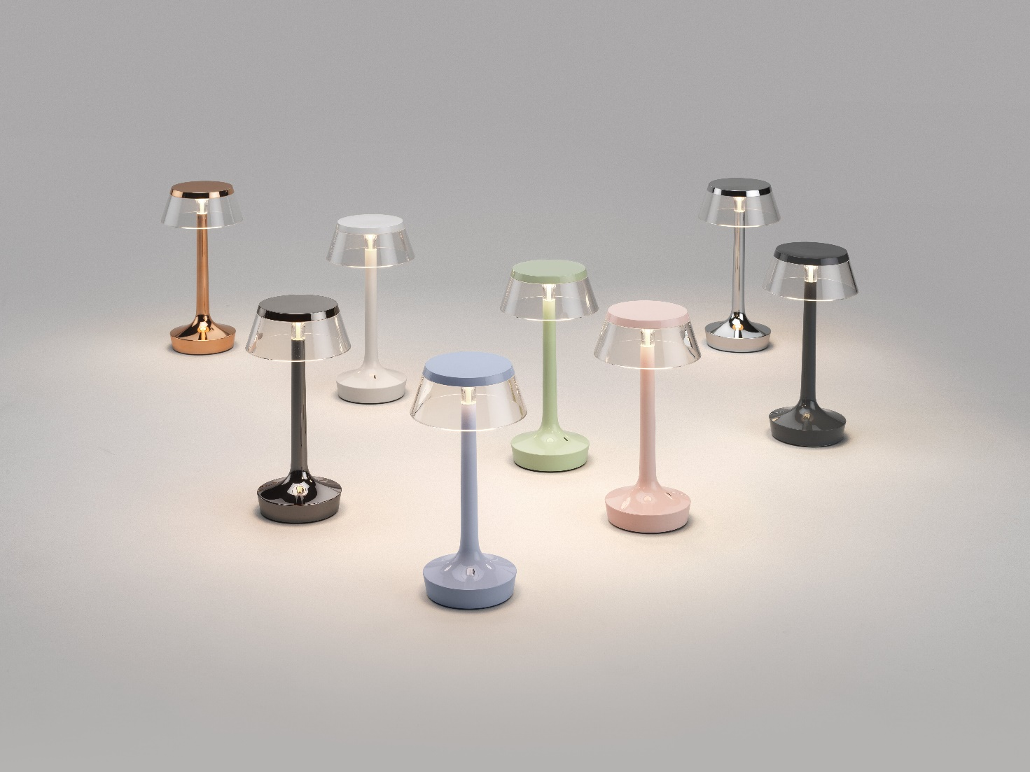

“A hopeful companion to carry around, with warmer and longer-lasting light to brighten up the future days to come. The Bon Jour Unplugged has a discreet elegance, now also joyful with its sentimental colors.’’ Ph.S

The tenth anniversary of an enlightened and sentimental companion

Launched by Flos in 2015, Philippe Starck's iconic Bon Jour Unplugged table lamp marked the arrival in the Flos catalogue of a new lamp typology - a portable table lamp with rechargeable battery - that would immediately conquer the public. With its essential design and discreet elegance, its revolutionary technology and unparalleled functionality, this small lamp, with its range of interchangeable crowns, has quickly become a fundamental accessory, an ethereal light to take with you everywhere and for any need.

2025 new edition

On the occasion of its tenth anniversary, Flos presents an updated version of Bon Jour Unplugged with a new sophisticated palette of colors, studied with its creator to enhance its emotional characteristics: from the soft and delicate tones of Almost White, Faded Blue and Fresh Mint, to the warm elegance of French Rose, to the contemporary refinement of Stormy Grey up to the bold Black Chrome, which join the classic Copper and Chrome finishes to offer a rich range of alternative solutions for every space and style.

The new edition includes the characteristic transparent crown, previously available as an accessory: a distinctive element that enhances its ethereal character and timeless design. The selection of interchangeable diffusers - Amber, Fumée, Fabric and Rattan - remains identical, allowing to customize the style and the light emission effect.

The technical update

The other important innovation for Bon Jour Unplugged is the brand new Color Tune light technology. Simply by holding down an optical sensor, you can precisely adjust the color of the light, to go from a very warm white (2200°K) to a welcoming white (2700°K) up to a clear white (3000°K). The lamp can therefore be adapted even more to the different needs for soft ambient lighting or a brighter, functional light. The light output can be easily adjusted from 3% to 30%, 70% and 100% via the optical sensor.

Technical characteristics

Wireless table lamp in ABS, aluminum, PMMA, powered by a rechargeable lithium-ion battery. A single charge provides up to 6 hours of continuous light. USB-C charging port.

